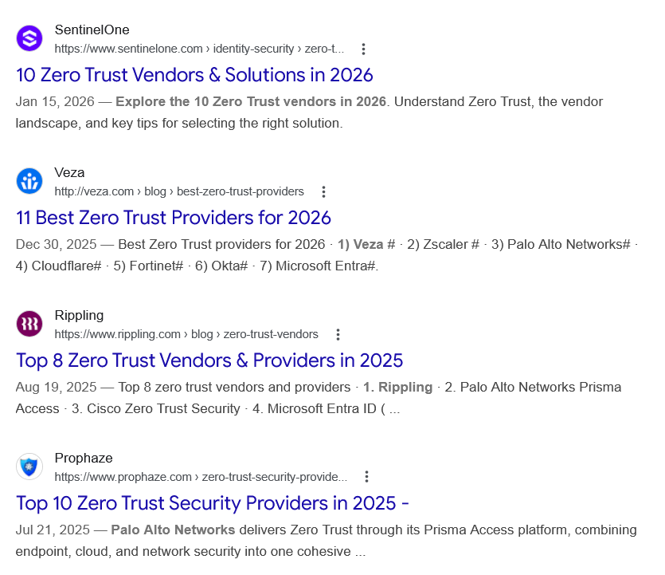
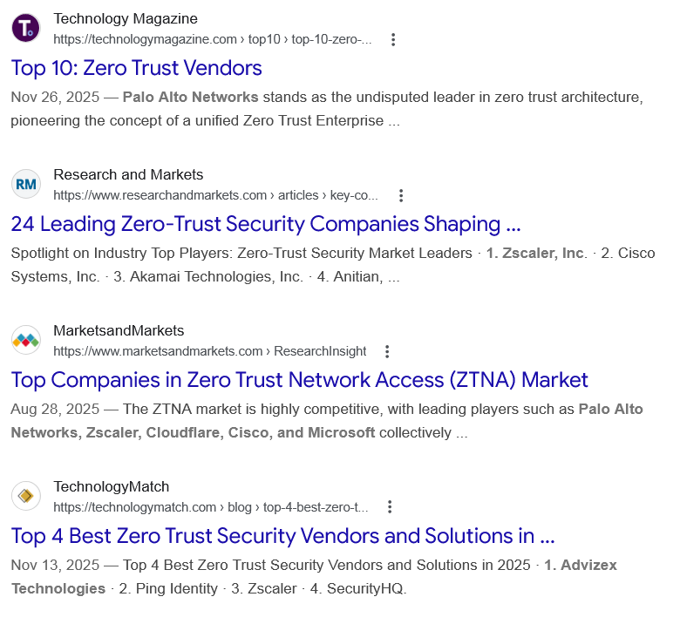
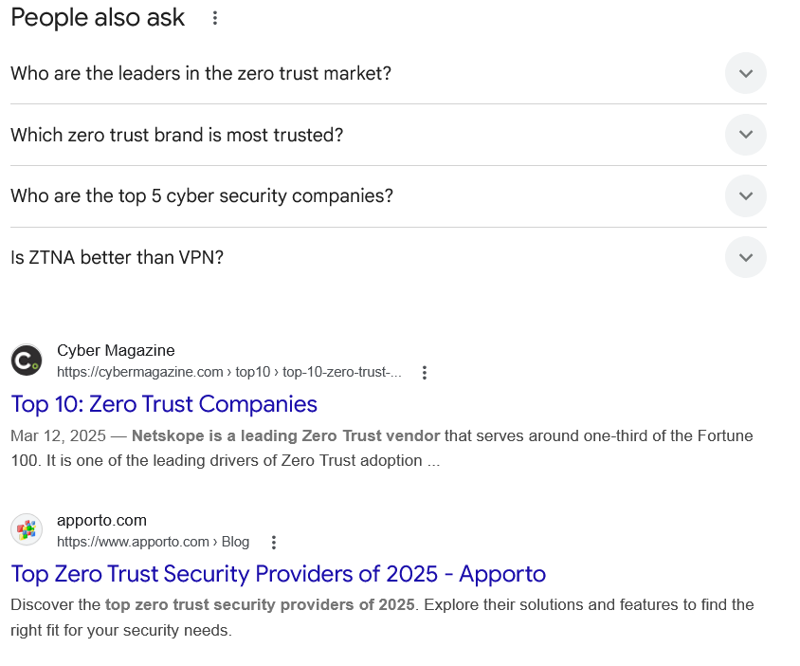
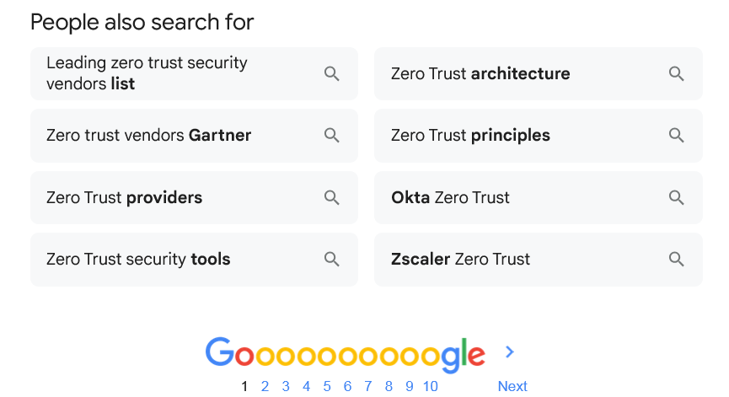

Web results

10 Zero Trust Vendors & Solutions in 2026

SentinelOne
https://www.sentinelone.com › identity-security › zero-t...

SentinelOne
https://www.sentinelone.com › identity-security › zero-t...
Jan 15, 2026 — Explore the 10 Zero Trust vendors in 2026. Understand Zero Trust, the vendor landscape, and key tips for selecting the right solution.

11 Best Zero Trust Providers for 2026

Veza
http://veza.com › blog › best-zero-trust-providers

Veza
http://veza.com › blog › best-zero-trust-providers
Dec 30, 2025 — Best Zero Trust providers for 2026 · 1) Veza # · 2) Zscaler # · 3) Palo Alto Networks# · 4) Cloudflare# · 5) Fortinet# · 6) Okta# · 7) Microsoft Entra#.

Top 8 Zero Trust Vendors & Providers in 2025

Rippling
https://www.rippling.com › blog › zero-trust-vendors

Rippling
https://www.rippling.com › blog › zero-trust-vendors
Aug 19, 2025 — Top 8 zero trust vendors and providers · 1. Rippling · 2. Palo Alto Networks Prisma Access · 3. Cisco Zero Trust Security · 4. Microsoft Entra ID ( ...

Top 10 Zero Trust Security Providers in 2025 -

Prophaze
https://www.prophaze.com › zero-trust-security-provide...

Prophaze
https://www.prophaze.com › zero-trust-security-provide...
Jul 21, 2025 — Palo Alto Networks delivers Zero Trust through its Prisma Access platform, combining endpoint, cloud, and network security into one cohesive ...

Top 10: Zero Trust Vendors

Technology Magazine
https://technologymagazine.com › top10 › top-10-zero-...

Technology Magazine
https://technologymagazine.com › top10 › top-10-zero-...
Nov 26, 2025 — Palo Alto Networks stands as the undisputed leader in zero trust architecture, pioneering the concept of a unified Zero Trust Enterprise ...

24 Leading Zero-Trust Security Companies Shaping ...

Research and Markets
https://www.researchandmarkets.com › articles › key-co...

Research and Markets
https://www.researchandmarkets.com › articles › key-co...
Spotlight on Industry Top Players: Zero-Trust Security Market Leaders · 1. Zscaler, Inc. · 2. Cisco Systems, Inc. · 3. Akamai Technologies, Inc. · 4. Anitian, ...

Top Companies in Zero Trust Network Access (ZTNA) Market

MarketsandMarkets
https://www.marketsandmarkets.com › ResearchInsight

MarketsandMarkets
https://www.marketsandmarkets.com › ResearchInsight
Aug 28, 2025 — The ZTNA market is highly competitive, with leading players such as Palo Alto Networks, Zscaler, Cloudflare, Cisco, and Microsoft collectively ...

Top 4 Best Zero Trust Security Vendors and Solutions in ...

TechnologyMatch
https://technologymatch.com › blog › top-4-best-zero-t...

TechnologyMatch
https://technologymatch.com › blog › top-4-best-zero-t...
Nov 13, 2025 — Top 4 Best Zero Trust Security Vendors and Solutions in 2025 · 1. Advizex Technologies · 2. Ping Identity · 3. Zscaler · 4. SecurityHQ.
People also ask
Who are the leaders in the zero trust market?
Key players driving the market include Palo Alto Networks, Zscaler, CrowdStrike, Okta, Cisco, Symantec, Fortinet, Akamai Technologies, Check Point Software Technologies, IBM, Microsoft, McAfee, Trend Micro, RSA Security, Illumio, Forcepoint, Tenable, Ping Identity, Cloudflare and CyberArk Leveraging advancements in ...

Top 10 Companies in the Zero Trust Security Market

Global Insight Services
https://www.globalinsightservices.com › insight › zero-tr...

Global Insight Services
https://www.globalinsightservices.com › insight › zero-tr...
Which zero trust brand is most trusted?
Palo Alto Networks
Palo Alto Networks stands as the undisputed leader in zero trust architecture, pioneering the concept of a unified Zero Trust Enterprise platform.Nov 26, 2025

Top 10: Zero Trust Vendors - Technology Magazine

Technology Magazine
https://technologymagazine.com › top10 › top-10-zero-...

Technology Magazine
https://technologymagazine.com › top10 › top-10-zero-...
Who are the top 5 cyber security companies?
With that in mind, here are the 20 largest cybersecurity companies in 2026, ranked by market capitalization (if publicly traded) or private valuation.
- Palo Alto Networks (PANW) ...
- CrowdStrike (CRWD) ...
- Cloudflare (NET) ...
- Fortinet (FTNT) ...
- Zscaler (ZS) ...
- CyberArk (CYBR) ...
- Leidos (LDOS) ...
- Check Point Software Technologies (CHKP)
More items...
•
Mar 4, 2026

The 20 Largest Cybersecurity Companies in 2026 - Programs.com

Programs.com
https://programs.com › resources › largest-cybersecurity-...

Programs.com
https://programs.com › resources › largest-cybersecurity-...
Is ZTNA better than VPN?
In cloud and hybrid environments, ZTNA's direct-to-app connections boost performance and scale, while VPNs can add latency and require more infrastructure. Many organizations run both, using ZTNA principles to secure modern applications and VPN for legacy needs, then shifting more workloads to ZTNA over time.

ZTNA vs VPN: Which One Is Better For Your Business | Cisco Duo

Cisco Duo
https://duo.com › learn › ztna-vs-vpn

Cisco Duo
https://duo.com › learn › ztna-vs-vpn

Web results

Top 10: Zero Trust Companies

Cyber Magazine
https://cybermagazine.com › top10 › top-10-zero-trust-...

Cyber Magazine
https://cybermagazine.com › top10 › top-10-zero-trust-...
Mar 12, 2025 — Netskope is a leading Zero Trust vendor that serves around one-third of the Fortune 100. It is one of the leading drivers of Zero Trust adoption ...

Top Zero Trust Security Providers of 2025 - Apporto

apporto.com
https://www.apporto.com › Blog

apporto.com
https://www.apporto.com › Blog
Discover the top zero trust security providers of 2025. Explore their solutions and features to find the right fit for your security needs.
People also search for

Leading zero trust security vendors list

Zero trust vendors Gartner

Zero Trust providers

Zero Trust security tools

Zero Trust architecture

Zero Trust principles

Okta Zero Trust

Zscaler Zero Trust

Page navigation
 | 1 | 2 | 3 | 4 | 5 | 6 | 7 | 8 | 9 | 10 | Next

